Appendix S4
Size-frequency distributions of A. amphisbaenians, B. lizards, and C. snakes
Data are from Appendix 1

A - Amphisbaenia
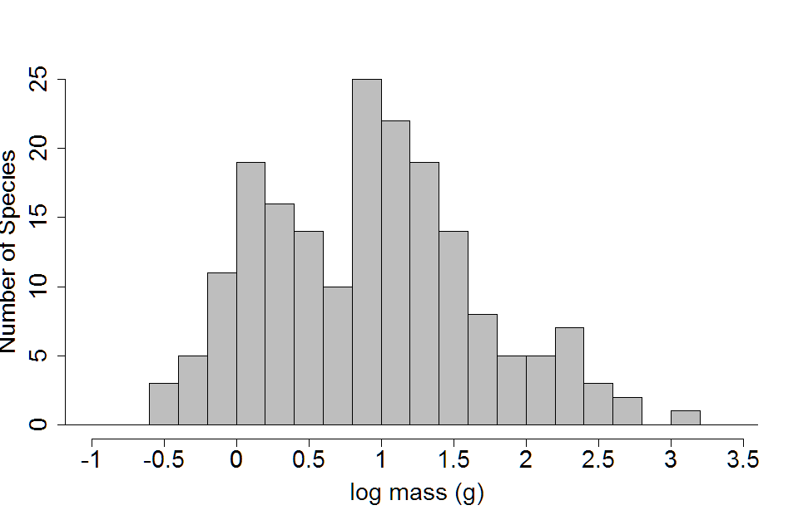

B - Sauria
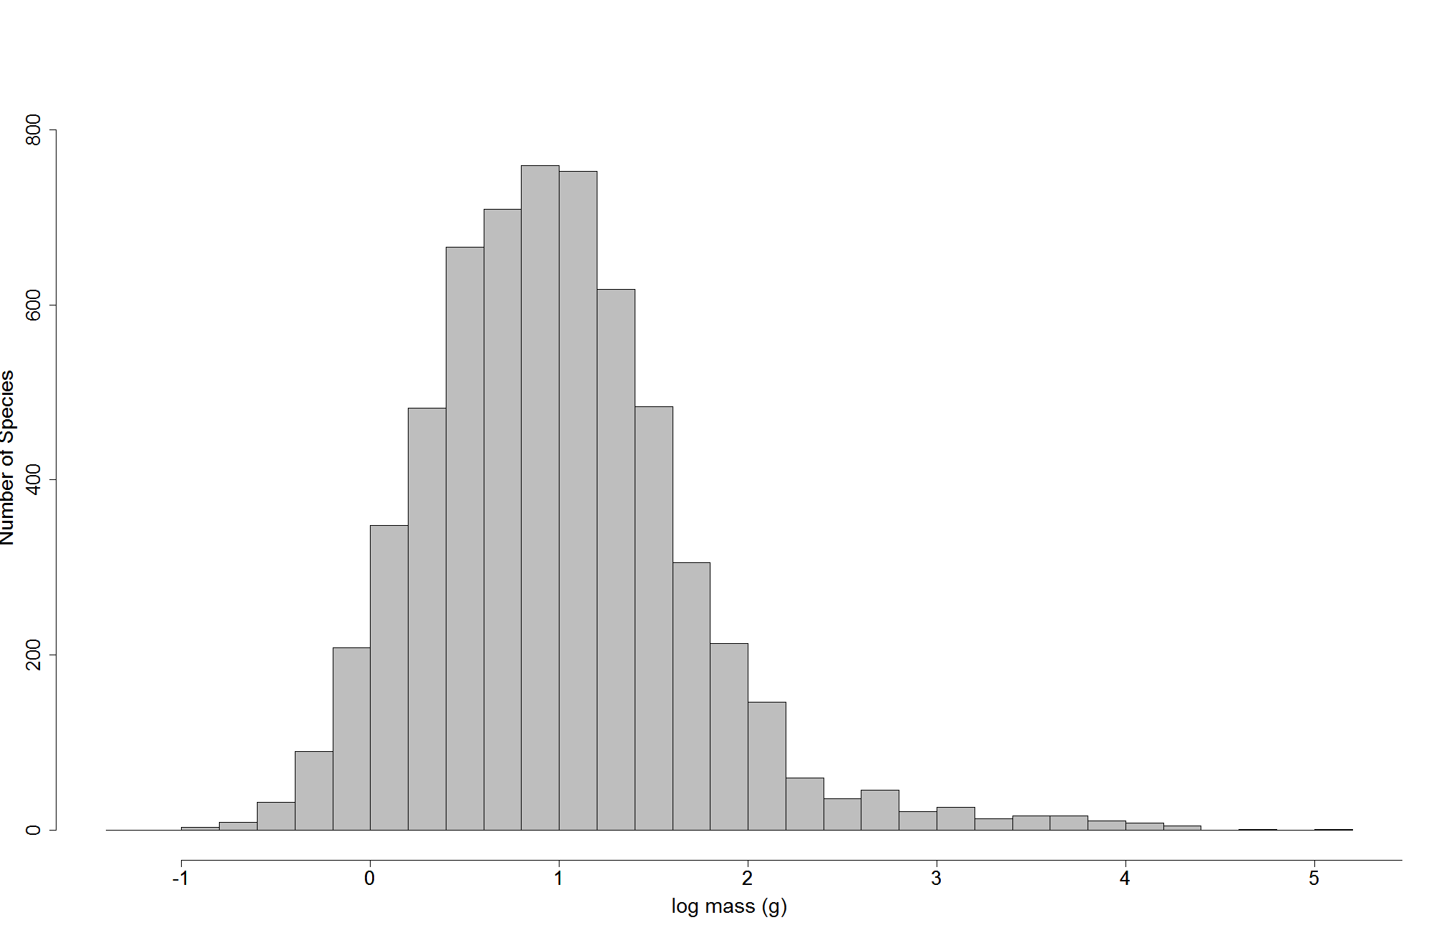

C - Serpentes

